Method1:

First transfer: color as content +style as style (preserve content color)

Second transfer: content as content + first transfer result as style (do not preserve content color)

**Model: VGG19**

Content layer: ReLU2-1

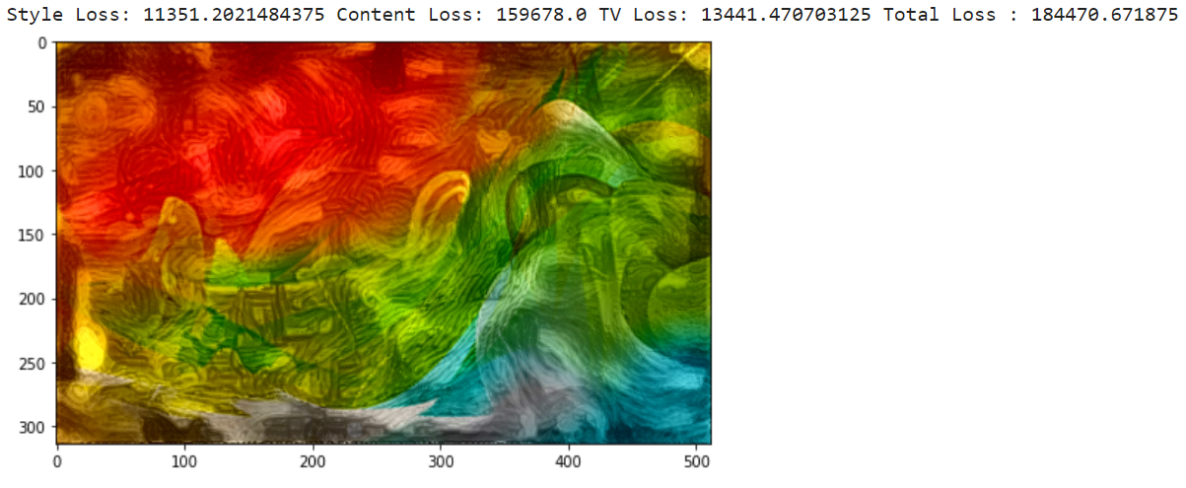

Style layer: 'relu1_2', 'relu2_2', 'relu3_3', 'relu4_4', 'relu5_4'

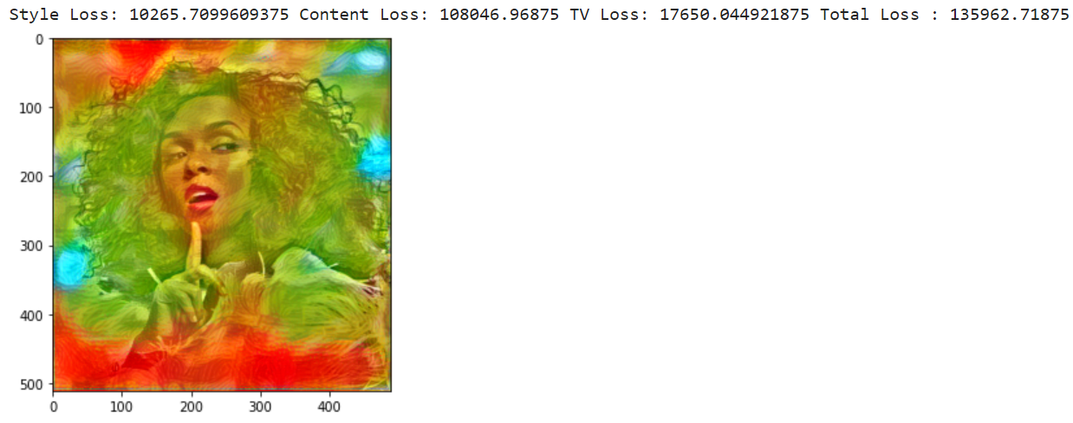

Content layer: ReLU3-1

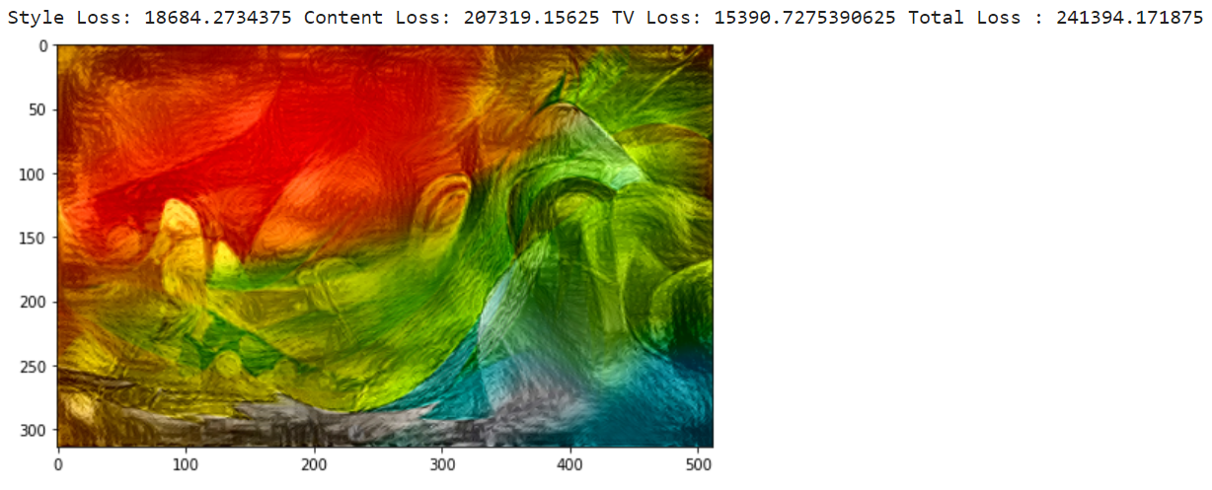

Style layer: 'relu1_2', 'relu2_2', 'relu3_3', 'relu4_4', 'relu5_4'

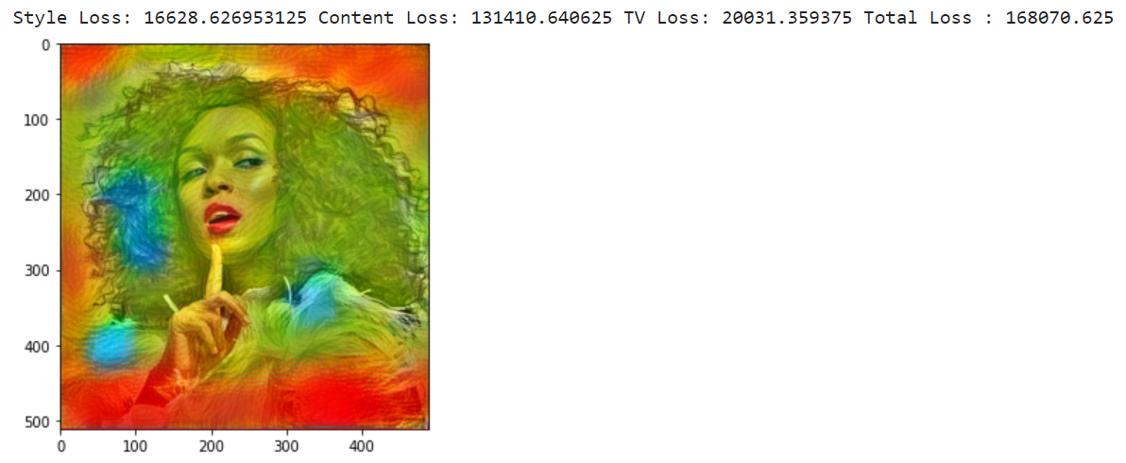

Content layer: ReLU4-1

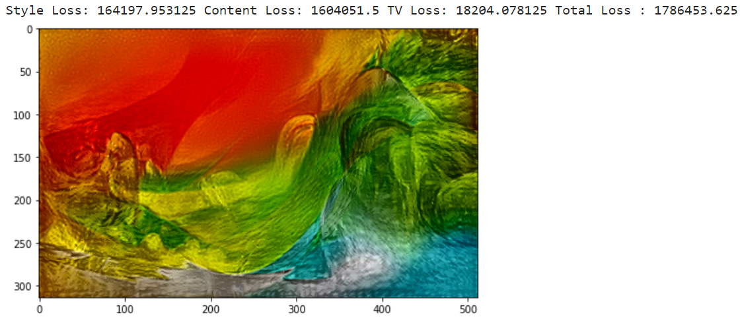

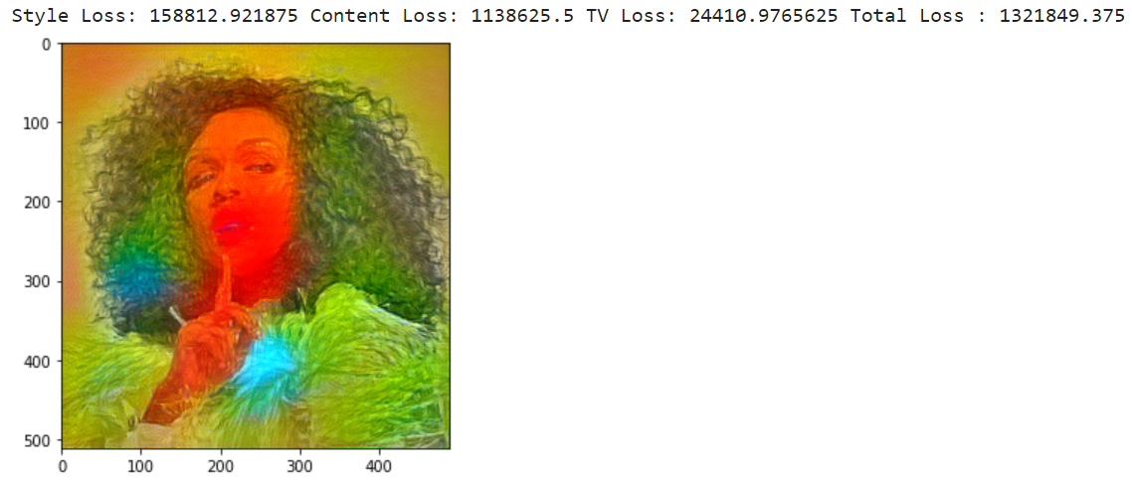

Content layer: ReLU5-1

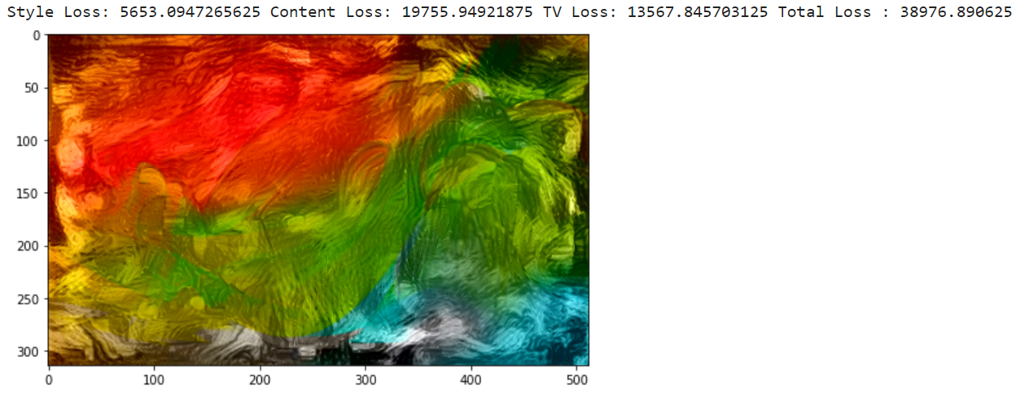

Style layer: 'relu1_2', 'relu2_2', 'relu3_3', 'relu4_4', 'relu5_4'

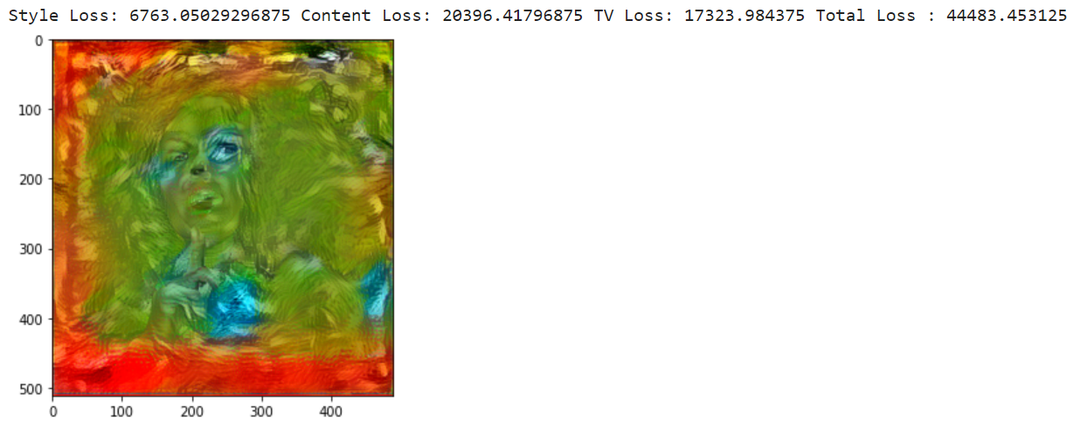

First transfer content layer: relu5-1

Second transfer content layer: relu3-1

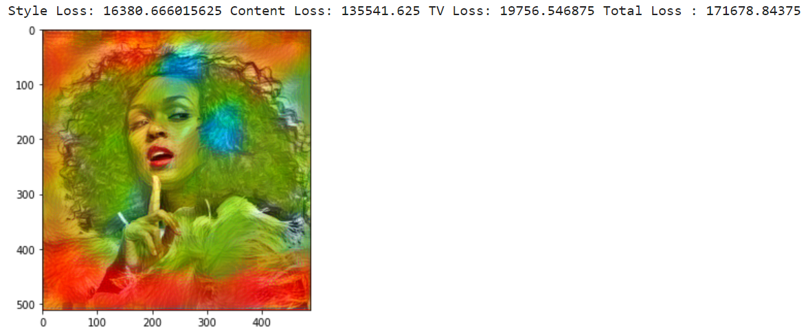

Model: vgg16

Content layer: ReLU2-1

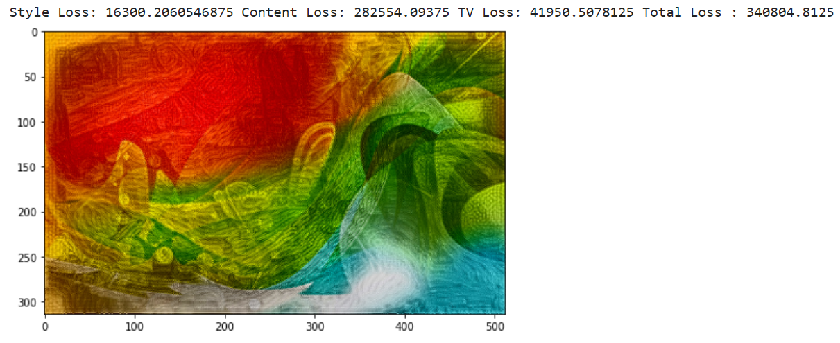

Style layer: 'relu1_2', 'relu2_2', 'relu3_3', 'relu4_3', 'relu5_3'

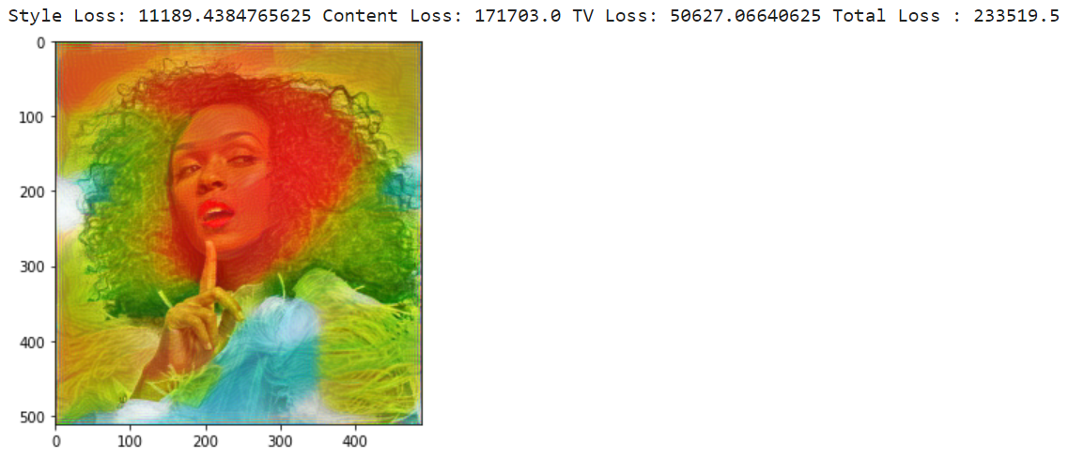

Content layer: ReLU3-1

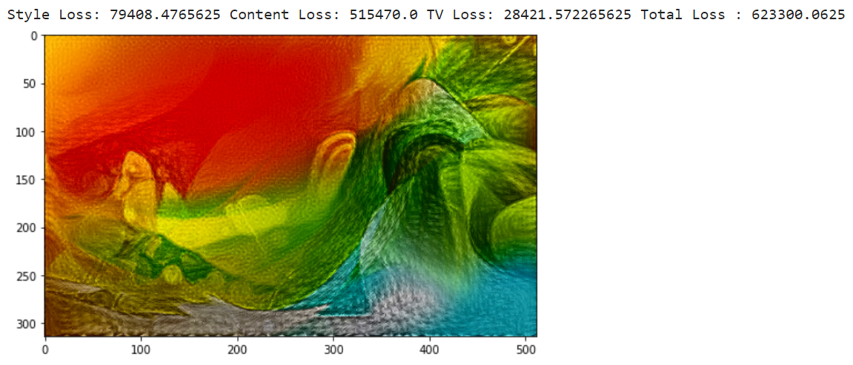

Style layer: 'relu1_2', 'relu2_2', 'relu3_3', 'relu4_3', 'relu5_3'

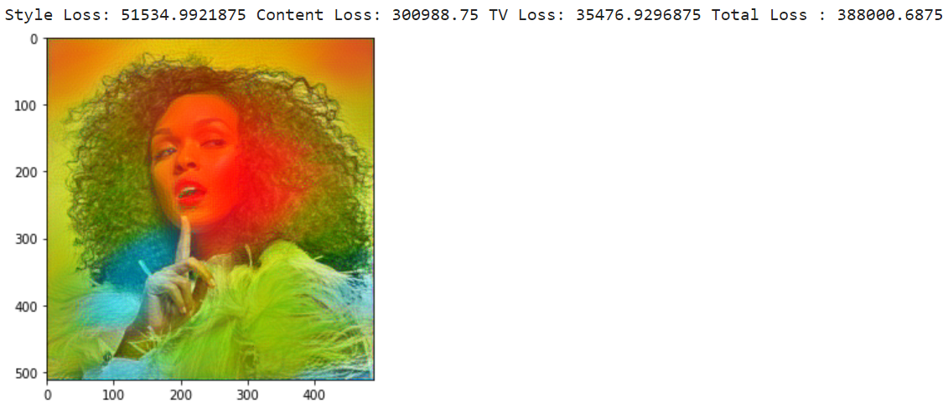

Content layer: ReLU4-1

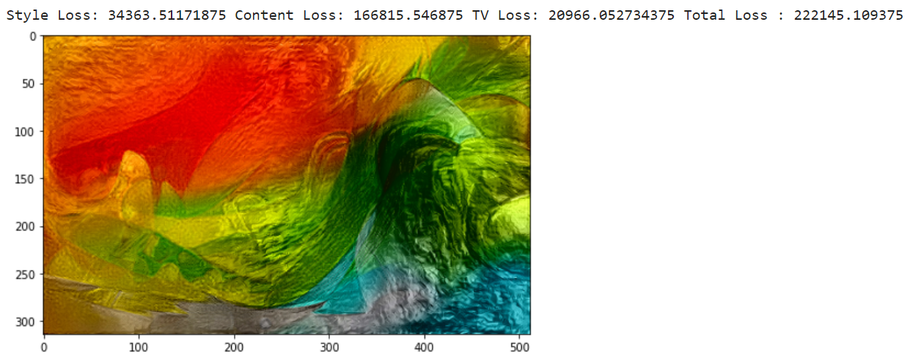

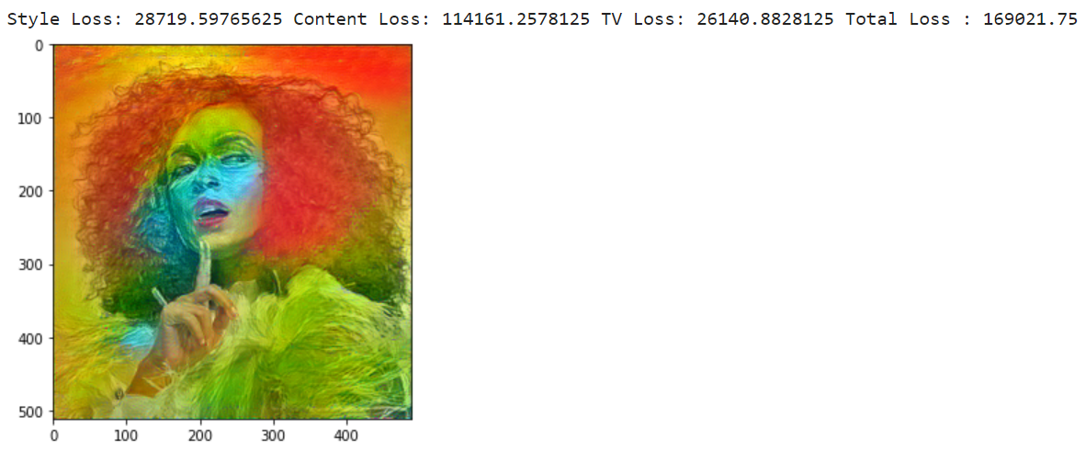

Content layer: ReLU5-1

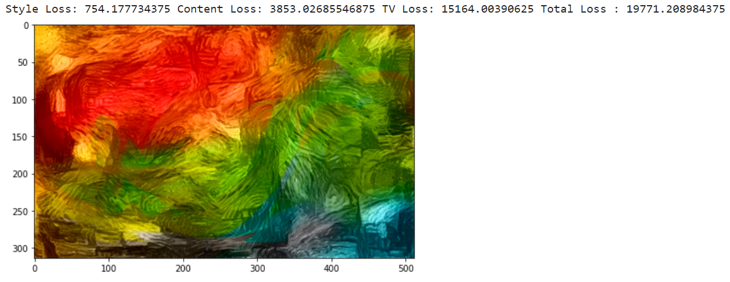

Style layer: 'relu1_2', 'relu2_2', 'relu3_3', 'relu4_3', 'relu5_3'

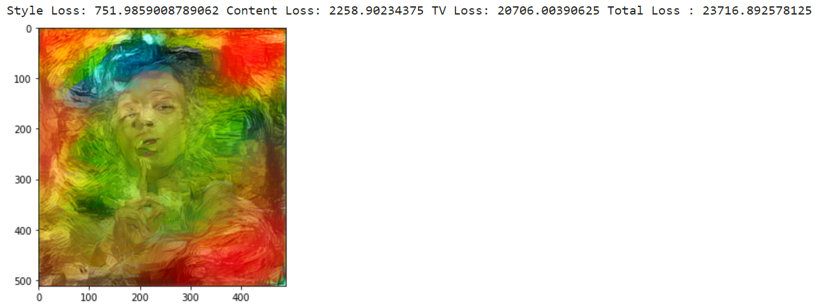

First transfer content layer: relu5-1

Second transfer content layer: relu3-1

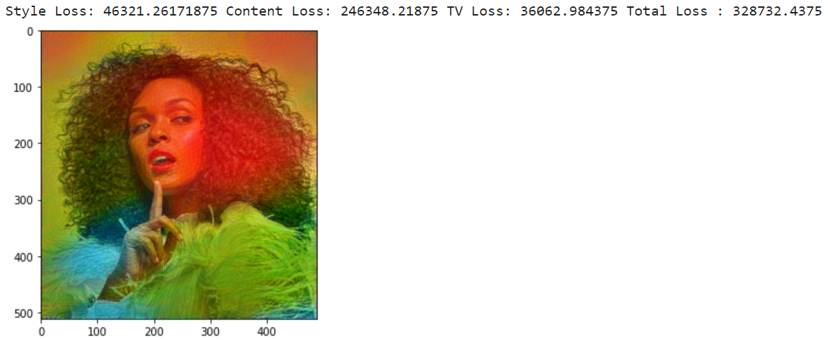

Method 2:

First cover color to style photo

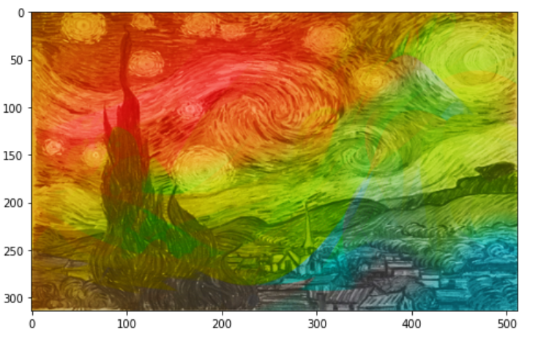

Second transfer: content as content + first transfer result as style (do not preserve content color)

Network: VGG16

Content layer: relu2-1

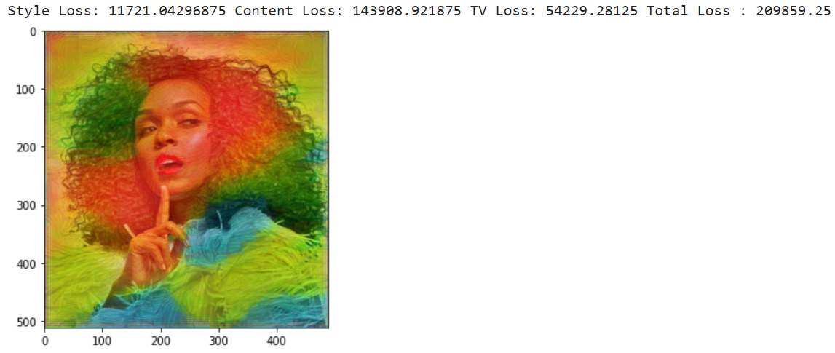

Content layer: relu3-1

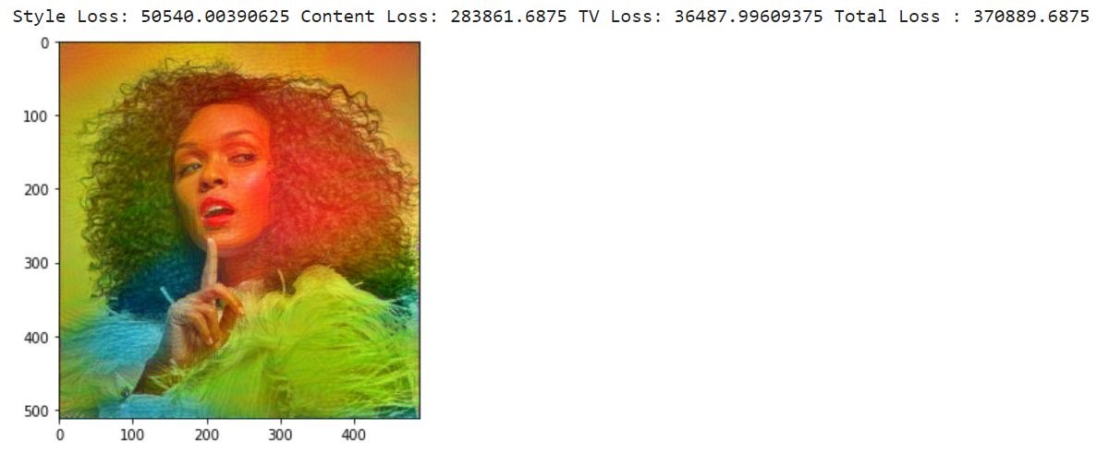

Content layer: relu4-1

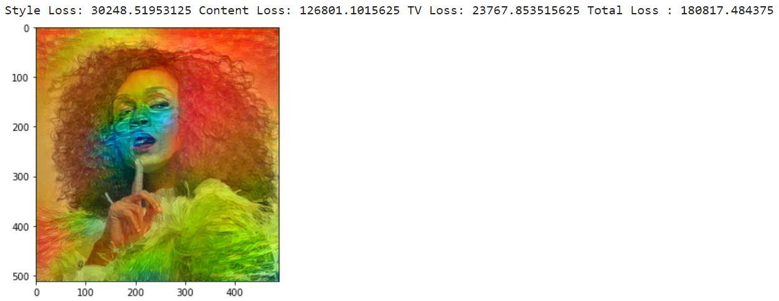

Content layer: relu5-1

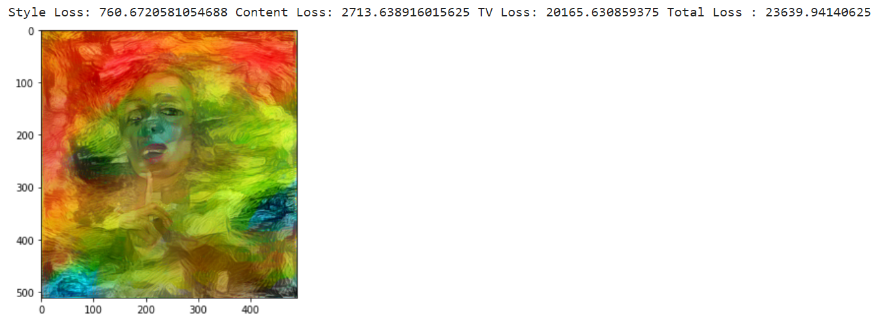

Network: VGG19

Content layer: relu2-1

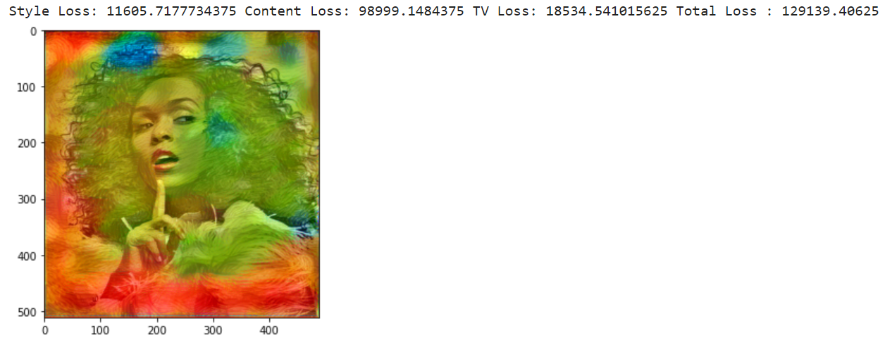

Content layer: relu3-1

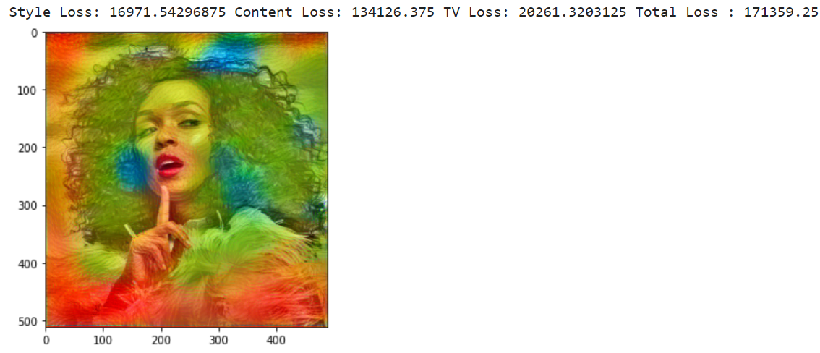

Content layer: relu4-1

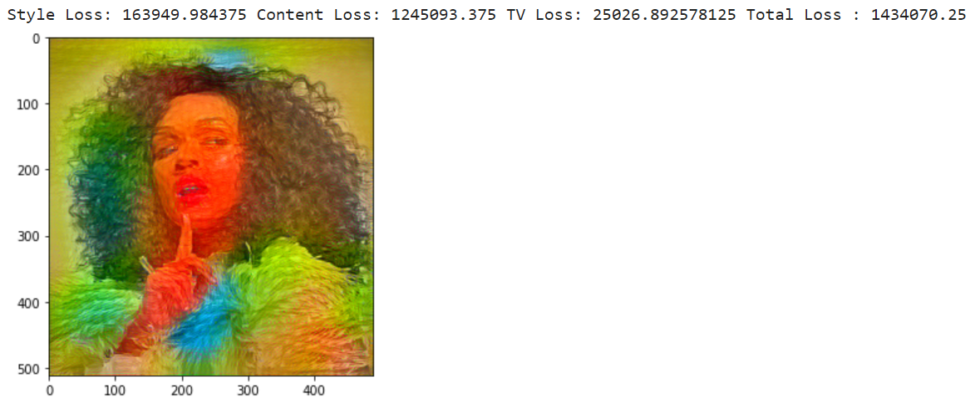

Content layer: relu5-1

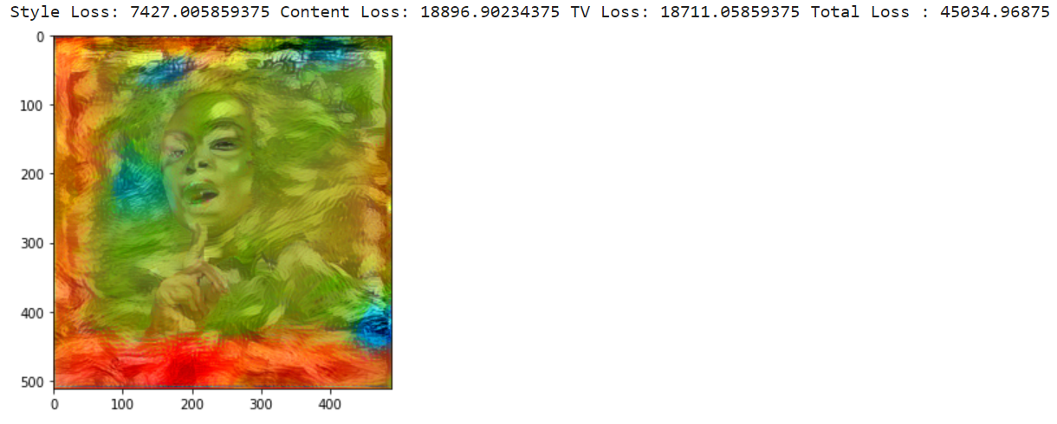

第一页

In our project, we mainly research how to transfer texture and color from different images to the content image and improve the quality of the resulting image. Now I will introduce the method we used to implement our problem.

第二页

We came up with two methods to transfer color and texture from different images to the content image. The first method is doing two times neural style transfer. The first step is to blend color and texture, in this way we can not only get the color from the color image and also get the texture from the style image. Next step is to transfer the new style image to the content, then we get the final result. The second method is first changing the color of the style image to the color of color image in style’s luminance channel, which looks like this. Then, do the neural style transfer to get the final result. We will discuss the different results of these two methods in next section.

第三页

We implement the transfer color function inspired by Gatys. They proposed to transfer style only in luminance channel to preserve content color. But the problem is the transfer of preserving color can only be implemented once. The result cannot be used in another style transfer. The result pixel matrix after preserving color style transfer is shown in the right picture. The type of the data is float32 which cannot be used in the next migration. The transfer function only accepts tensor matrix with type unit8 and the range should be in [0,255]. therefore, we try to normalize the matrix to the required range.

第四页

So The left figure shows the original resulting image after the first transfer by using plot show function. The right figure shows the image after we normalization. It is obvious that the brightness of the image on the right is lower than the left one. This is because some colour information is lost when performing BGR interval correction.

第五页

Then we decided to do contrast stretching to recover the color feature. The result is as in the right figure. Although there is still some difference between the original figure and processed image. With this problem solved we can perform multiple style transfers.

第六页

Having finished implementing the fusion of texture, colour and content, the next stage we were focusing on how to improve the quality of the resulting map. As mentioned in the problem analysis, when using different convolutional layers as the content layer there are different results in feature extraction, we would like to further investigate whether the best output layer when performing two style migrations is the same as the best output layer for a single migration. We have used the convolutional layer in the orange box in the figure as a different content feature extraction layer to compare its effect.

第七页

In addition, we wanted to compare the impact of using different networks on our results. This is because differences in network structure can lead to differences in the effectiveness of the extracted features. We will discuss the difference in the next section. Next, let’s move to Jingyang to discuss our results.